Output:
Compiled using online C compiler
(https://www.programiz.com/c-programming/online-compiler)

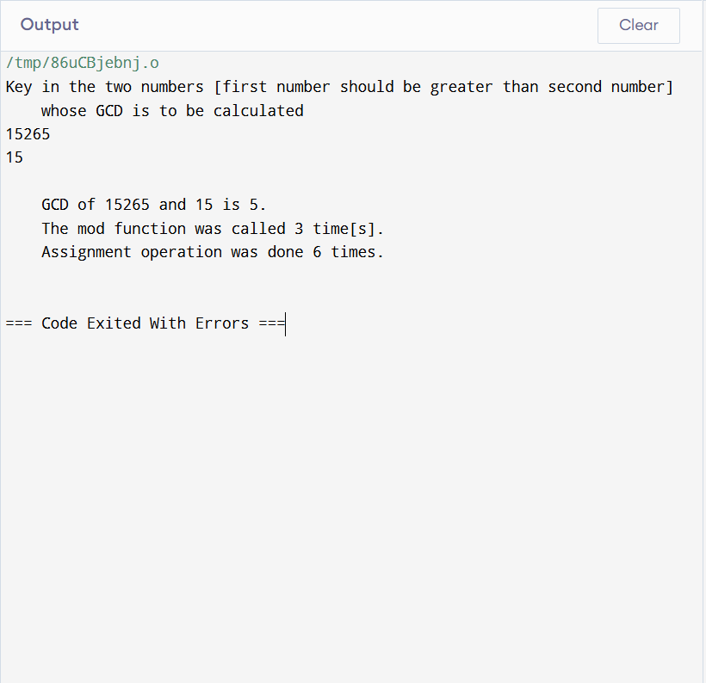

Output:
Compiled using online C compiler
(https://www.programiz.com/c-programming/online-compiler)

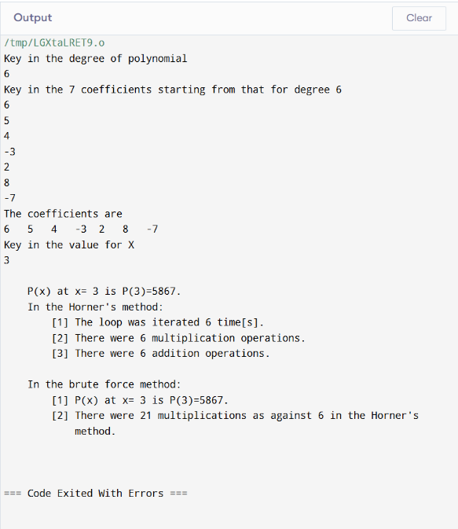

Output:
Compiled using online C compiler
(https://www.programiz.com/c-programming/online-compiler)

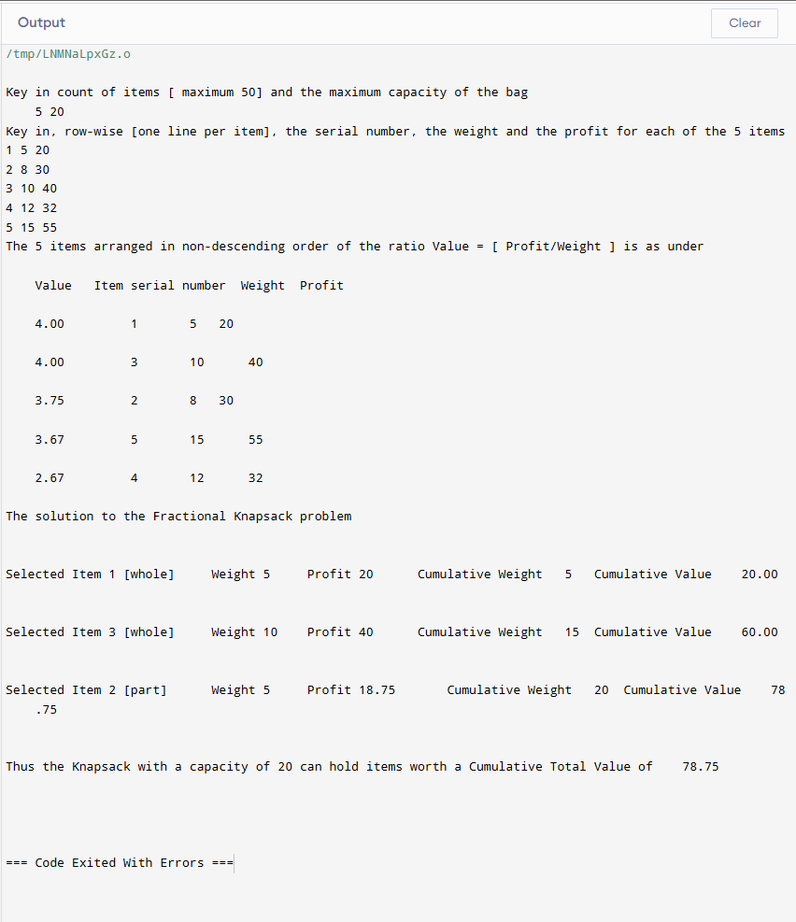

Output:
Compiled using online C compiler
(https://www.programiz.com/c-programming/online-compiler)

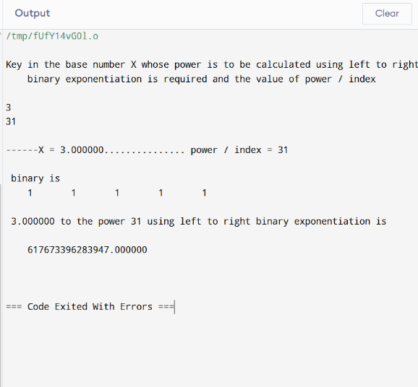

Output:
Compiled using online C compiler
(https://www.programiz.com/c-programming/online-compiler)

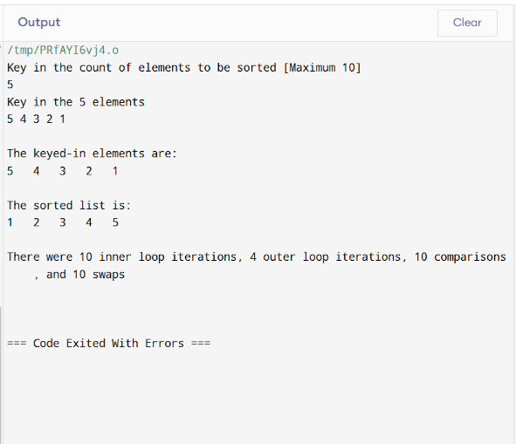

Output:
Compiled using online C compiler
(https://www.programiz.com/c-programming/online-compiler)

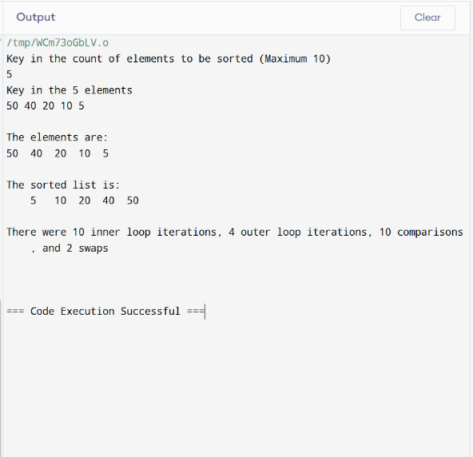

Output:
Compiled using online C compiler
(https://www.programiz.com/c-programming/online-compiler)

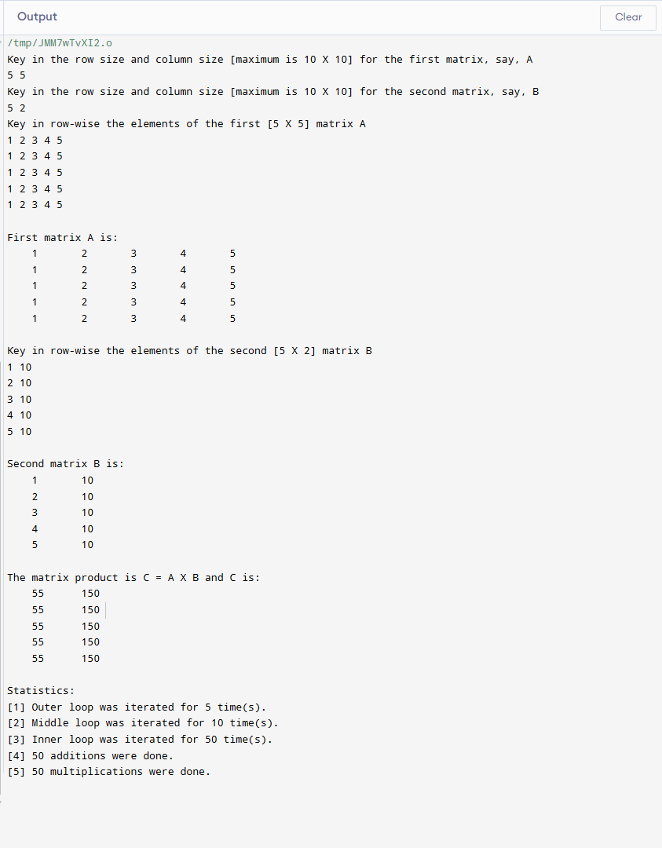

Q8) MST Prime algorithm

#include <stdio.h>
#include <stdlib.h>

#define MAX 10
#define TEMP 0
#define PERM 1
#define infinity 9999
#define NIL -1

struct edge
{
int u;
int v;
};

int n;
int adj[MAX][MAX];
int predecessor[MAX];
int status[MAX];
int length[MAX];

void create_graph();
void maketree(int r, struct edge tree[MAX]);
int min_temp();

int main()
{
int wt_tree = 0;
int i, root;
struct edge tree[MAX];
printf("\n\n vertices are numbered from 0 to end, say, 0, 1,2,...,9; key in edge in the format <start vertex> <SPACE> <end vertex>, say, without quotes \", \"0 19\". \n\n");
create_graph();
printf("\nKey in root vertex: ");
scanf("%d", &root);

maketree(root, tree);
printf("\nEdges to be included in spanning tree are: \n");
for (i = 1; i <= n-1; i++)
{
printf("%d->", tree[i].u);
printf("%d\n", tree[i].v);
wt_tree += adj[tree[i].u][tree[i].v];
}
printf("\nWeight of spanning tree is: %d\n", wt_tree);
return 0;
}
/* End of main() */

void maketree(int r, struct edge tree[MAX])
{
int current, i;
int count = 0; // Number of vertices in the tree
/* initialize all vertices */
for (i = 0; i < n; i++)
{
predecessor[i] = NIL;
length[i] = infinity;
status[i] = TEMP;
}
/* Make length of root vertex 0 */
length[r] = 0;
while (1)
{
/* search for temporary vertex with minimum length
and make it current vertex */
current = min_temp();
if (current == NIL)
{
if (count == n - 1) /* No temporary vertex left */
return;
else // Temporary vertices left with length infinity

{
printf("\nGraph is not connected, No spanning tree possible");
exit(1);
}
}
/* Make the current vertex permanent */
status[current] = PERM;
/* Insert the edge ( predecessor[current], current) into the tree
except when the current vertex is root */
if (current != r)
{
count++;
tree[count].u = predecessor[current];
tree[count].v = current;
}

for (i = 0; i < n; i++)
if (adj[current][i] > 0 && status[i] == TEMP)
if (adj[current][i] < length[i])
{
predecessor[i] = current;
length[i] = adj[current][i];
}
}
} /* End of make_tree */

/* Returns the temporary vertex with minimum value of length
Return NIL if no temporary vertex left or
all temporary vertices left have path length infinity*/
int min_temp()
{
int i;
int min = infinity;
int k = -1;
for (i = 0; i < n; i++)
{
if (status[i] == TEMP && length[i] < min)
{

min = length[i];
k = i;
}
}
return k;
} /* End of min_temp() */

void create_graph()
{
int i, max_edges, origin, destin, wt;
printf("\nKey in number of vertices: ");
scanf("%d", &n);
max_edges = n * (n - 1) / 2;
for (i = 1; i <= max_edges; i++)
{
printf("\nKey in edge %d(-1 -1 to quit) : ", i);
scanf("%d %d", &origin, &destin);
if ((origin == -1) && (destin == -1))
break;
printf("\nKey in weight for that edge: ");
scanf("%d", &wt);
if (origin >= n || destin >= n || origin < 0 || destin < 0)
{
printf("\nInvalid edge\n");
i--;
}
else
{
adj[origin][destin] = wt;
adj[destin][origin] = wt;
}
}
}

Output:
Compiled using GCC compiler for windows.

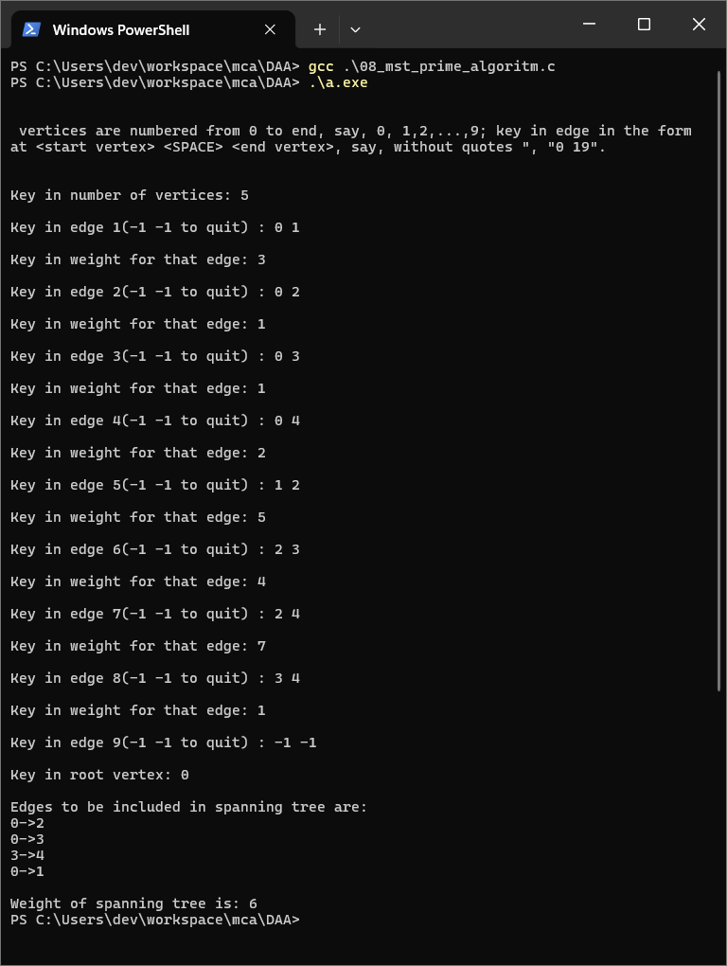

Q9) Matrix chain multiplication

// Matrix chain multiplication and how to place the parentheses

#include <stdio.h>
#include <limits.h>
#define infinity 999999999
long int m[20][20];
int s[20][20];
int d[20], i, j, n;

void print_optimal(int i, int j)
{
if (i == j)
printf("A%d", i);
else
{
printf("(");
print_optimal(i, s[i][j]);
print_optimal(s[i][j] + 1, j);
printf(")");
}
}

void matmultiply(void)
{
long int q;
int k;
for (i = n; i > 0; i--)
{
for (j = i; j <= n; j++)
{
if (i == j)
m[i][j] = 0;
else
{
for (k = i; k < j; k++)
{

q = m[i][k] + m[k + 1][j] + d[i - 1] * d[k] * d[j];
if (q < m[i][j])
{
m[i][j] = q;
s[i][j] = k;
}
}
}
}
}
}
int MatrixChainOrder(int d[], int i, int j)
{
if (i == j)
return 0;
int k;
int min = INT_MAX;
int count;
for (k = i; k < j; k++)
{
count = MatrixChainOrder(d, i, k) +
MatrixChainOrder(d, k + 1, j) + d[i - 1] * d[k] * d[j];
if (count < min)
min = count;
}
// Return minimum count
return min;
}
void main()
{
int k;
printf("\nKey in the count of matrices\t");
scanf("%d", &n);
for (i = 1; i <= n; i++)
for (j = i + 1; j <= n; j++)
{
m[i][j] = 0;

m[i][j] = infinity;
s[i][j] = 0;
}
printf("\n\nKey in the dimensions\n");
for (k = 0; k <= n; k++)
{
printf("d%d:", k);
scanf("%d", &d[k]);
}
matmultiply();
printf("\nMinimum cost elements m[i][j] are\n");
for (i = 1; i <= n; i++)
{
printf("\n\n\t");
for (j = i; j <= n; j++)
printf("m[%d][%d]:%ld\t", i, j, m[i][j]);
}
// cost matrix

printf("\n\nMinimum cost diagonal matrix is\n");
for (i = 1; i <= n; i++)
{
printf("\n\n");
for (j = 1; j <= n; j++)
printf("\t%ld", m[i][j]);
}
printf("\n\n Minimum number of multiplications is : %d", MatrixChainOrder(d, 1, n));
printf("\n\n");
i = 1, j = n;
printf("\n Multiplication Sequence for the %d matrices is ", n);
print_optimal(i, j);
printf("\n\n");
}

Output:
Compiled using GCC compiler for windows.

